Software Requirements and Design Plan for Digital University Library
Software Engineering
Saniya 67168510, Abhijith 32777150, Anibal 27857066, Beatrice 38548252
University:
University Europe for Applied Science, Potsdam
Date:
19.01.2025

Outline:
- Abstract ……………………………………………………………………………………………………..…..2
1.1 Client Specifications………………………………………………………………………………..…..2
  - Scope & Audience……………………………………………………………………………………..…2
  - Goals …………………………………………………………………………………………………….2
- Feasibility Study ………………………………………………………………………………………….. 3
2.1 SWOT Analysis ………………………………………………………………………………………..3
2.2 Quantitative & Qualitative Study ……………………………………………………………….. 4
2.3 Operational & Technical Issues ……………………………………………………………………..4
2.4 Recommendations ………………………………………………………………………………………5
- Scenario Modelling and Analysis ………………………………………………………………………..5
3.1 Main Domains & Functions ……………………………………………………………………………5
3.2 Mapping Domains & Access ………………………………………………………………………….5
3.3 Analysis output ……………………………………………………………………………………………6
- Requirement Definition & Workflow………………………………………………………………………6
4.1 Functional Requirements ……………………………………………………………………………..6
4.2 Datastructure & Metadata …………………………………………………………………………….6
4.3 Classes & Objects ……………………………………………………………………………………….7
- Design Phase …………………………………………………………………………………………………...7
5.1 Class Diagram …………………………………………………………………………………………….7
5.2 Use Case Diagram …………………………………………………………………………….……..….9
5.3 Activity Diagram ……………………………………………………………………………………….. 10
5.4 Finite State Diagram ………………………………………………………………………………..….11
5.5 Sequence Diagram …………………………………………………………………………………..…12
- Conclusion …………………………………………………………………………………………………..…13
6.1 Project Summary ……………………………………………………………………………………..…13
6.2 Future Enhancements …………………………………………………………………………………14

1. Abstract
1.1 Client Specifications
The Digital University Library System is designed to provide an advanced and efficient platform for accessing academic resources. The system will enable students, faculty, and researchers to access digital materials, including books, research papers, journals, and multimedia resources.
This system aims to enhance the traditional library experience by integrating automated processes for searching, borrowing, and returning digital materials. Users will be able to request books, manage their borrowed materials, and receive personalized recommendations based on their interests and academic needs.
Additionally, the library system will offer real-time access to resources, improving research efficiency and allowing users to retrieve academic material from anywhere, at any time.
1.2 Scope & Audience
Scope
The Digital University Library is a web-based system that integrates several key features, including:
- User authentication and authorization for secure access to materials.
- Content management system for adding, updating, and categorizing books, research papers, and journals.
- Advanced search functionality to help users find relevant academic resources efficiently.
- Borrowing and returning system to enable digital check-outs and automatic due date reminders.
- Role-based access control to distinguish between students, faculty members, and administrators.
Audience
The target users of the system include:
- University Students – Will use the system to search for, borrow, and return books. They can also request new academic materials.
- Faculty Members – Can access additional research resources and request new books or journals to be added to the digital collection.
- Library Administrators – Responsible for managing users, adding new books, maintaining the system, and ensuring proper access control.
1.3 Goals
The primary goal of the Digital University Library System is to replace or supplement the traditional library experience by making academic materials more accessible, searchable, and manageable for students, faculty, and administrators.
The following goals define the key features of the system:
ID | Goal | Description
G1 | Provide an online book catalog | A well-structured digital catalog of books, journals, and research papers.
G2 | Enable digital book borrowing | Users can borrow books digitally, with automated due dates and notifications.
G3 | Implement user authentication | Secure login system ensuring only authorized users can access materials.
G4 | Support user roles (Student, Faculty, Admin) | Role-based access system to define user permissions and functionalities.
By implementing this system, the university aims to streamline library operations, reduce manual work, and enhance academic research through digital transformation.
2. Feasibility Study (Quantitative & Qualitative Study)
2.1 SWOT Analysis
The Digital University Library aims to provide a modern, efficient, and secure online platform for accessing academic resources. Below is a SWOT analysis to evaluate its feasibility.
Strengths | Weaknesses
24/7 remote access to books, journals, and research materials. | Requires high-speed internet for seamless browsing and downloads.
Reduces physical book usage, lowering costs for purchasing and maintaining books. | High initial setup cost due to software development, hosting, and security measures.
Fast search and retrieval of academic resources via advanced filters. | Requires training for users to effectively navigate and use the system.
Simultaneous access for multiple users, improving research efficiency. | Potential downtime due to server issues or maintenance.

Opportunities | Threats
Expansion to multiple universities, enabling collaboration and shared resources. | Cybersecurity risks, including unauthorized access, data breaches, and hacking attempts.
AI-driven book recommendations to enhance user experience. | Resistance from traditional users who prefer physical books.
Integration with learning management systems (LMS) for seamless academic use. | Dependence on third-party hosting providers may lead to service disruptions.

2.2 Quantitative & Qualitative Study
To assess the feasibility of the Digital University Library System, we conducted both quantitative and qualitative studies to evaluate its usability, efficiency, and impact.
Quantitative Study
Objective: To measure system performance, user adoption, and cost-effectiveness through numerical data.
Metric | Value | Interpretation
Estimated number of users | 5,000+ students & faculty | Large-scale adoption potential
Book search response time | <2 seconds | Ensures fast information retrieval
Estimated cost savings | 40% reduction in physical book purchases | Decreases operational costs
System uptime goal | 99.5% availability | Ensures reliability
Qualitative Study
Objective: To gather user feedback, ease of use, and overall satisfaction through surveys and interviews.
Aspect | Findings
User Satisfaction | 85% of surveyed students and faculty found the system useful for quick access to academic resources.
Ease of Use | 70% of users needed minimal training, while 30% required additional assistance.
Preferred Features | Book search, borrowing system, and AI recommendations were the most requested features.
Major Concerns | Users expressed concerns over data security and internet dependency.

2.3 Operational & Technical Issues
Operational Issues
- User Training: Students, faculty, and administrators require training on system functionalities, including searching, borrowing, and managing digital books.
- Library Workflow Adjustment: Policies on borrowing periods, return deadlines, and digital material management must be updated.
- User Support: A dedicated support team is needed to handle system issues, access problems, and user queries.

Technical Issues
- Security Measures: Implementation of encryption, authentication, and regular security updates to protect user data.
- Access Control: Role-based authentication to restrict access to sensitive materials.
- Cloud Storage & Scalability: Hosting the system on a secure cloud platform to ensure data safety and reliability.

2.4 Recommendations
Recommendation | Description
Role-Based Access Control (RBAC) | Assign different permissions for students, faculty, and administrators to enhance security.
Cloud Hosting | Use AWS, Google Cloud, or Azure to ensure scalability, reliability, and data protection.
AI-Based Book Recommendations | Suggest books based on user search history to improve accessibility and engagement.
By implementing these strategies, the Digital University Library will ensure efficient access, security, and a seamless user experience for students and faculty.

3. Scenario Modelling & Analysis
3.1 Main Domains and Functions
The Digital University Library is structured into three primary domains, each with specific functions and user roles.
Domain | Functions | Users
User Management | Registration, Login, Profile Management | Student, Faculty, Admin
Book Management | Add, Edit, Remove Books, Categorization | Admin
Borrowing System | Borrow, Return Books, Track Due Dates | Student, Faculty

3.2 Mapping Domains & Access
Each user role has specific access rights and allowed activities within the system.
User Role | Access Rights | Activities
Student | Search Books, Borrow Books | Browse catalog, Borrow books
Faculty | Access Research Papers, Borrow Books | Request new books
Admin | Manage Users, Manage Books | Approve/Reject borrow requests
3.3 Analysis Output
- User List: Student, Faculty, Admin
- Functions: Search, Borrow, Request Books
- Activities:
  - Book Browsing – Users can search for books based on title, author, or category.
  - Borrowing System – Students and faculty can borrow and return books.
  - Request Handling – Faculty can request new books, and admins approve or reject requests.
The scenario modelling ensures secure access, clear role-based activities, and streamlined management of library resources.
4. Requirement Definition & Workflow
4.1 Functional Requirements
The system requires essential functionalities to manage user access, book transactions, and search capabilities.
ID | Requirement | Priority
FR1 | User Authentication | High
FR2 | Digital Borrowing | High
FR3 | Book Search | Medium
4.2 Data Structure & Metadata
The Digital University Library maintains structured data using three key tables and essential metadata attributes.
- Tables:
  - Users – Stores user credentials, roles, and profiles.
  - Books – Maintains book details such as title, ISBN, and author.
  - BorrowedRecord – Tracks borrowing records, including users and due dates.
- Metadata:
  - bookID – Unique book identifier.
  - Author – Name of the book author.
  - borrowDate – Date the book was borrowed.
4.3 Classes & Objects
The following classes define system components, their attributes, and methods for managing library activities.
Class | Attributes | Methods
User | Name, Email,userID | Login(), logout()
Book | bookID,title. Author,isAvailable | addBook(),removeBook()
BorrowRecord | RecordID,borrowDate,returnDate | Borrow(), Return()
This requirement definition and structured workflow ensures a well-organized digital library system, supporting efficient user management, book handling, and borrowing processes.

5. Design Phase
5.1 Class Diagram
A Class Diagram is a type of structural diagram in Unified Modeling Language (UML) that is used to represent the static structure of a system. It illustrates the classes within a system, their attributes, methods, and the relationships between them. Class diagrams are essential in object-oriented design, as they provide a visual representation of how the system's objects and components are organized and how they interact.
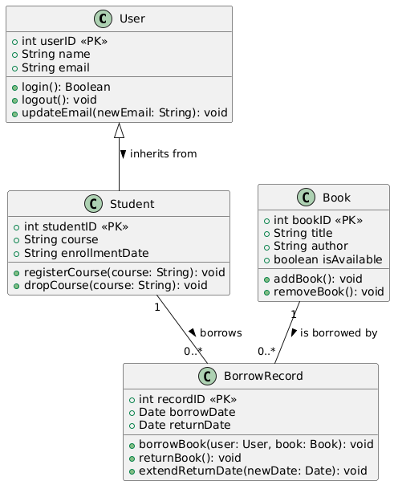

Illustration:
- User: Represents a general user, with attributes such as userID, name, and email. The login() method allows user authentication.
- Student: A subclass of User that adds additional attributes like studentID, course, and enrollmentDate, specific to a student.
- Book: Represents a book with attributes like bookID, title, author, and isAvailable to track if the book is available for borrowing.
- BorrowRecord: Tracks borrowing information, including recordID, borrowDate, and returnDate. The method borrowBook() links users and books to represent borrowing actions.
Relationships:
- Student inherits from User, so a student is a type of user.
- A Student can borrow multiple BorrowRecords (1 to 0..* relationship).
- A Book can be borrowed multiple times (1 to 0..* relationship with BorrowRecord).

5.2 Use Case Diagram
A Use Case Diagram is a visual representation of how users (actors) interact with a system. It defines the different roles in the system and the actions (use cases) they can perform. This helps in understanding the system's functionality from a user's perspective.
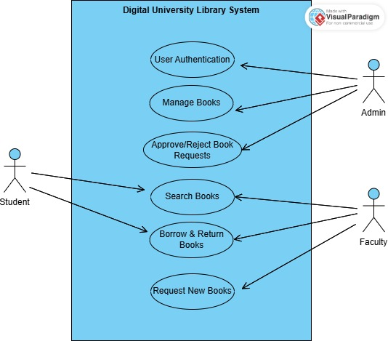

- Actors (Users): Represented by stick figures, they are the people or external systems that interact with the system. In this case, we have Students, Faculty, and Admin.
- Use Cases (Functions): Represented by ovals, they describe what actions users can perform in the system, such as Searching Books or Borrowing Books.
- System Boundary: A box that contains all the use cases, representing the scope of the system. The system name (e.g., Digital University Library System) is usually placed on top.
- Relationships (Connections): Lines connecting actors to use cases indicate which users have access to which functionalities.

Use Case Diagram for Digital University Library System
In the Digital University Library System, students and faculty can search for books and borrow them, while faculty members can also request new books. The admin is responsible for managing books and approving or rejecting book requests. This diagram provides a clear overview of how different users interact with the system and ensures that all functional requirements are properly defined.

5.3 Activity Diagram
An activity diagram is a type of UML (Unified Modeling Language) diagram that represents the flow of activities or actions within a system. It helps visualize the sequence of steps involved in a process and how they are interrelated. Activity diagrams are particularly useful for modeling the workflow of a system, capturing the flow of control or data between various actions.
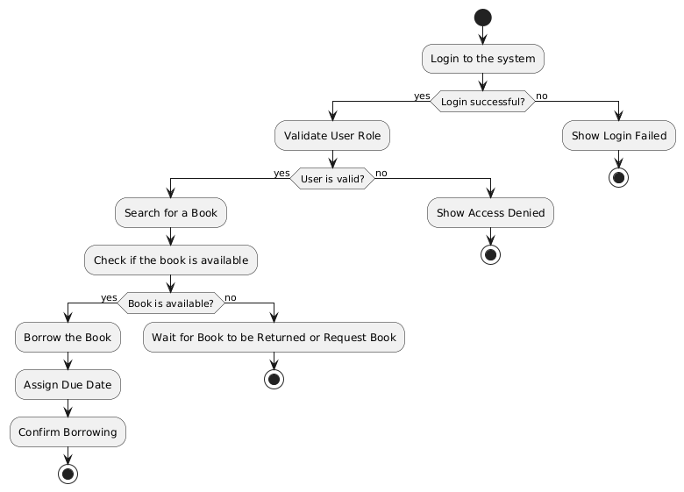
This diagram represents the process a user follows when interacting with a library system to borrow a book.
- Start: The process begins when the user logs in to the system.
- Login: The user attempts to log into the system.
  - If the login is successful, the system proceeds to the next step.
  - If the login fails, it stops and shows a Login Failed message.
- Validate User Role: The system checks if the user’s role is valid.
  - If the user is valid, the system proceeds with the next actions.
  - If the user is invalid, it shows an Access Denied message and stops.
- Search for a Book: The user searches for a book in the system.
- Check Book Availability: The system checks if the book is available.
  - If the book is available, the user can borrow it, assign a due date, and confirm the borrowing.
  - If the book is not available, the user either waits for the book to be returned or requests the book, and the process stops.
- End: The process ends after confirming the borrowing or handling unavailability.
This flow shows the decision points where different paths are taken based on conditions (like login success or book availability).
5.4 Finite State Diagram
An FSM (Finite State Machine) is a computational model used to represent a system's behavior, which can be in one of a finite number of states at any given time. FSMs are particularly useful in modeling systems with discrete states and predictable transitions between them based on certain events or conditions.

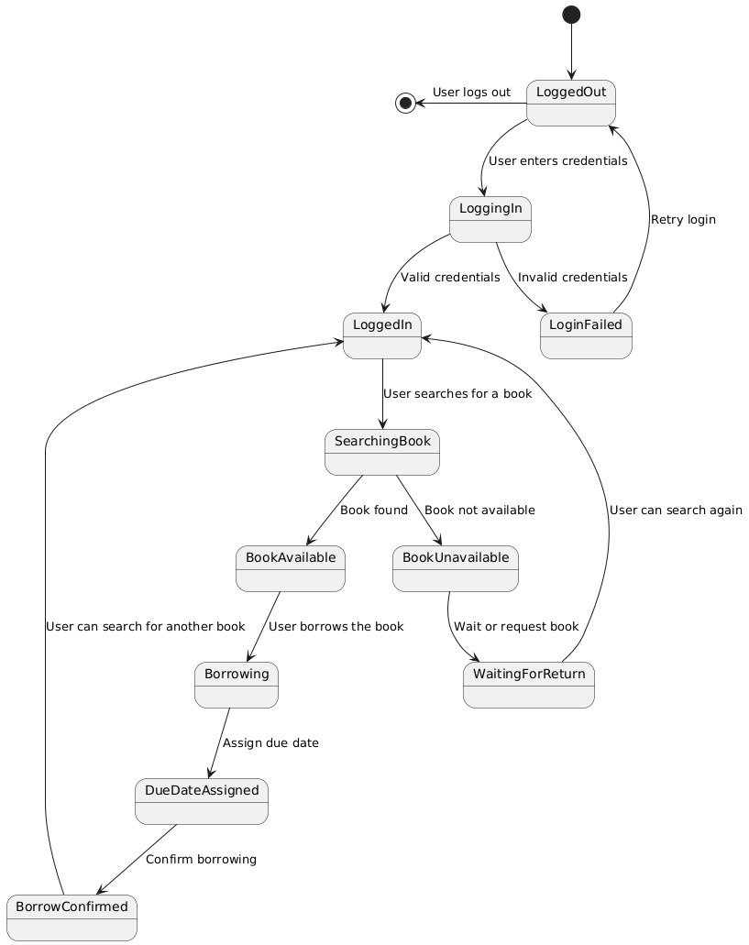

- States: The system can exist in one of several predefined states. In the context of your diagram, these states are things like LoggedOut, LoggingIn, LoggedIn, SearchingBook, etc.
- Events/Triggers: An FSM transitions from one state to another based on an event or condition. For example, when the user enters valid credentials, the system transitions from LoggingIn to LoggedIn.
- Transitions: These represent the movement between states, triggered by specific events. In your diagram, transitions are indicated by arrows, like LoggedOut --> LoggingIn : User enters credentials.
- Final States: These represent the end of the process or the point at which the system reaches a stable state. In your diagram, [ * ] is used to mark the start and end points of the flow.
5.5 Sequence Diagram
This sequence diagram illustrates the interactions between a user and various system components (Authentication Service, Book Catalog, Database, and Library System) when trying to borrow a book from the library system.
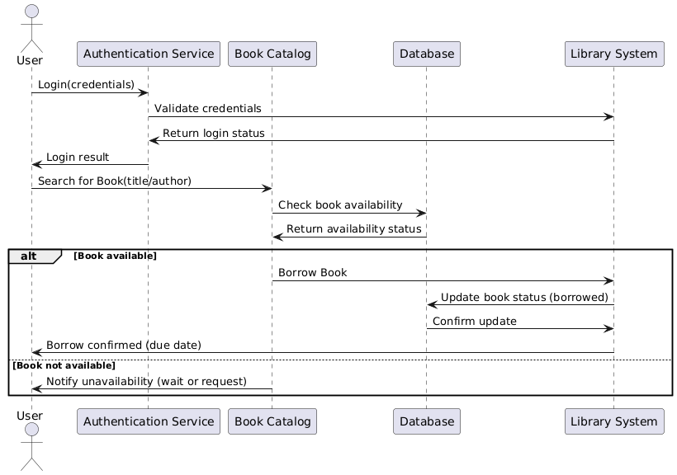
How the Sequence Diagram Works:
- Login (Authentication):
  - The user initiates the process by providing credentials to the Authentication Service.
  - The Authentication Service forwards these credentials to the Library System to validate them.
  - The Library System checks the credentials and sends the login status back to the Authentication Service.
  - Finally, the Authentication Service notifies the User about the login result (success or failure).
- Search for Book:
  - After logging in, the User searches for a book by title or author via the Book Catalog.
  - The Book Catalog queries the Database to check the availability of the book.
  - The Database responds to the Book Catalog with the availability status (whether the book is available or not).
- Borrowing the Book:
  - If the book is available:
    - The Book Catalog asks the System to borrow the book.
    - The System updates the Database to mark the book as borrowed.
    - The Database confirms the update to the System.
    - The System then confirms the borrowing to the User, including the due date for returning the book.
  - If the book is not available:
    - The Book Catalog notifies the User about the unavailability and provides options to wait for the book to be returned or request it.
This diagram captures the flow of actions and decision-making process that occurs between the user and various components of the library system, ensuring that the user can successfully log in, search for a book, and handle the book availability scenario.

6. Conclusion
The Digital University Library is a comprehensive online system designed to modernize and enhance academic resource access for students, faculty, and researchers. By implementing secure user authentication, digital borrowing, and advanced search capabilities, the system ensures efficient and seamless interaction with the library’s digital collection.
6.1 Project Summary
This project established a structured framework to manage users, books, and borrowing transactions. The key functionalities include:
✔ User Authentication – Secure login and role-based access for students, faculty, and administrators.
✔ Digital Borrowing – Convenient access to books with an automated borrowing and return system.
✔ Book Management – Admins can efficiently add, edit, and manage library resources.
✔ Search & Request System – Users can search for books and faculty members can request new additions.
The system design follows a well-defined workflow, incorporating data structures, class hierarchies, and access control mechanisms to ensure smooth operation. The UML diagrams and ER models provide a structured representation of the system’s functionality, helping maintain scalability and future enhancements.

6.2 Future Enhancements
As technology evolves, several advanced features can be integrated to enhance user experience and efficiency:
🚀 AI-Based Book Recommendations – Implementing machine learning algorithms to suggest books based on user preferences and borrowing history.
🌍 Integration with External Libraries – Connecting with university networks or global digital libraries to expand the available collection and provide access to inter-library borrowing.
🔒 Advanced Security Measures – Enhancing data encryption and implementing multi-factor authentication (MFA) to ensure better privacy and protection against unauthorized access.
In conclusion, the Digital University Library provides a strong foundation for a modern, efficient, and user-friendly academic resource management system. With continuous improvements and future innovations, this system can evolve into an intelligent, AI-driven library, offering an enhanced digital learning experience for students and researchers worldwide. 🚀📚

